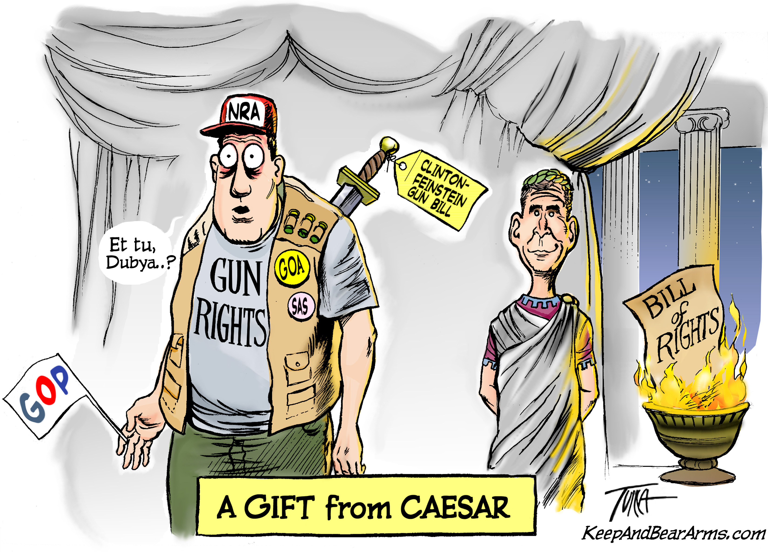

President Bush says he supports renewing the Clinton/Feinstein semi-auto gun ban.

GUN OWNER POLL:

KeepAndBearArms.com surveyed 8,677 gun owners, April 14-20, 2003.

92% of the respondents said they would not vote for President Bush’s re-election if he signed a renewal of the Clinton/Feinstein gun ban.

Do gun-banning Republican congressmen think they’ll have better luck?

Are they aware of the Coalition Against the Semi-auto Ban?

http://KeepAndBearArms.com/AWBan

